Li-Ion charging:

Charging and discharging:

* The voltage is constant when charging
* Charging stops when a maximum voltage threshold is reached (85%), not charging it fully saves the battery life.
* Fully charging results in temperature rise of 5C
* Charging with high current will quickly fill the battery to 70%
* Charging and discharging the Li-Ion on the same time increases the stress level of the battery, which damages the battery health
* Overcharging Li-Ion will plate metallic lithium on the anode. The cathode material becomes an oxidizing agent, loses stability, and produces carbon dioxide (CO2). The cell pressure rises and if the charge is allowed to continue, the current interrupt device (CID) responsible for cell safety disconnects, and the cell might eventually vent with flame
* Discharging is cut-off at 3V

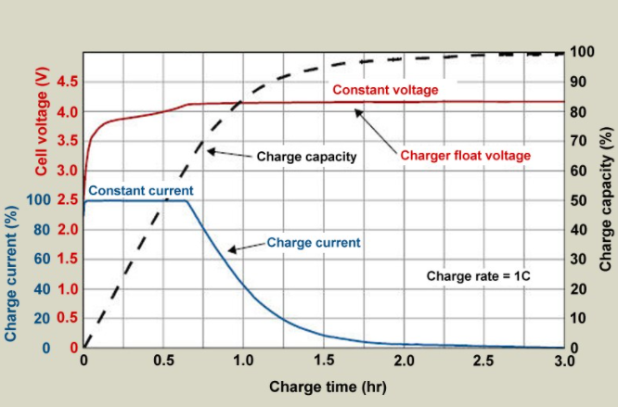

Li-Ion protection required:

* Charge current
* Charge temperature
* Discharge current
* Over-voltage
* Over-charge protection
* Reverse polarity protection
* Li-Ion over discharge
* Over temperature

When load is lower than input, the Li-Pol can be charged.

BMS is required to keep the battery within the safety operation region in terms of voltage, current, and temperature during the charge, the discharge.